|  |  |
| --- | --- |
| **DATE** | 15 November 2022 |
| **TEAM ID** | PNT2022TMID26051 |
| **PROJECT NAME** | Smart Crop Protection System for Agriculture |

**CREATE A CLOUD OBJECT STORAGE SERVICE**

**STEP 1:** Login to the IBM cloud account

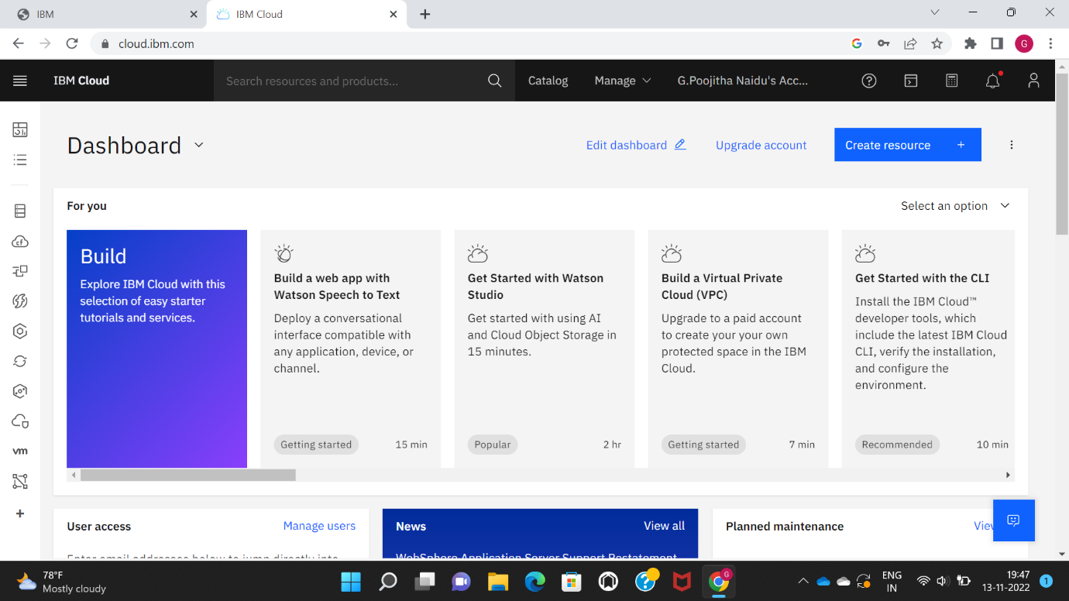

STEP 2: Open the catalog click on the storage. If you scroll down Object storage is available click on it 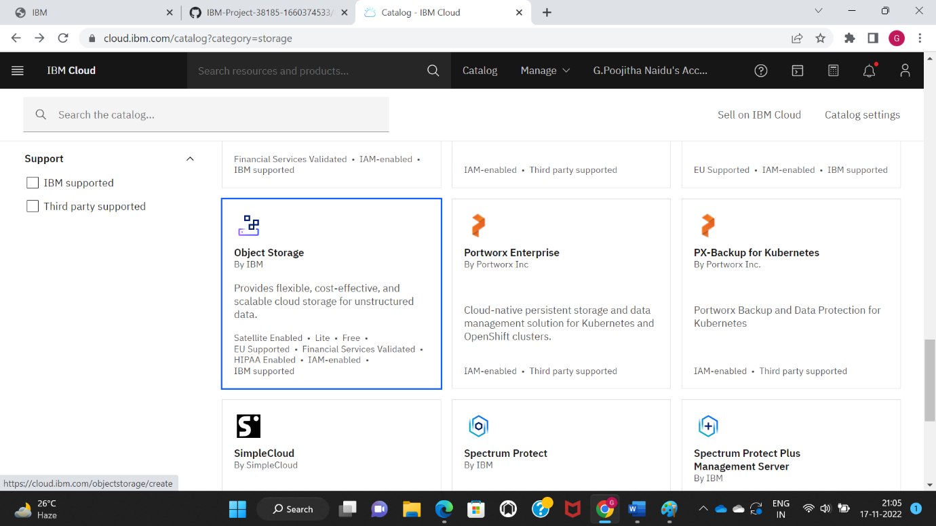

STEP 3: Click on object storage to create an account in cloud object storage

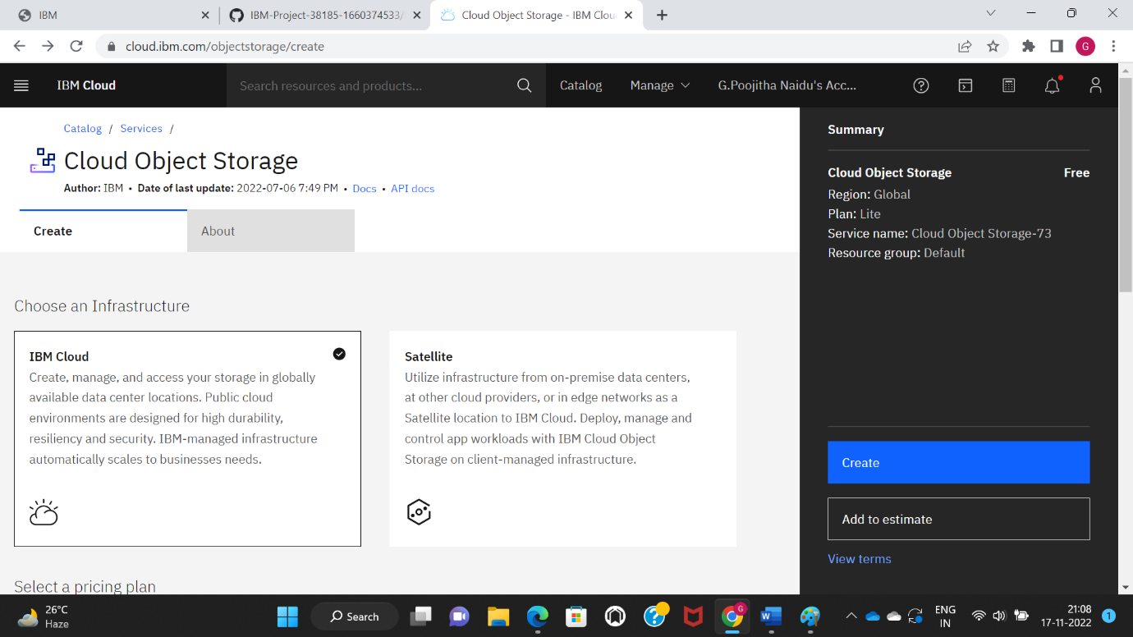

STEP 4: The cloud object storage is created

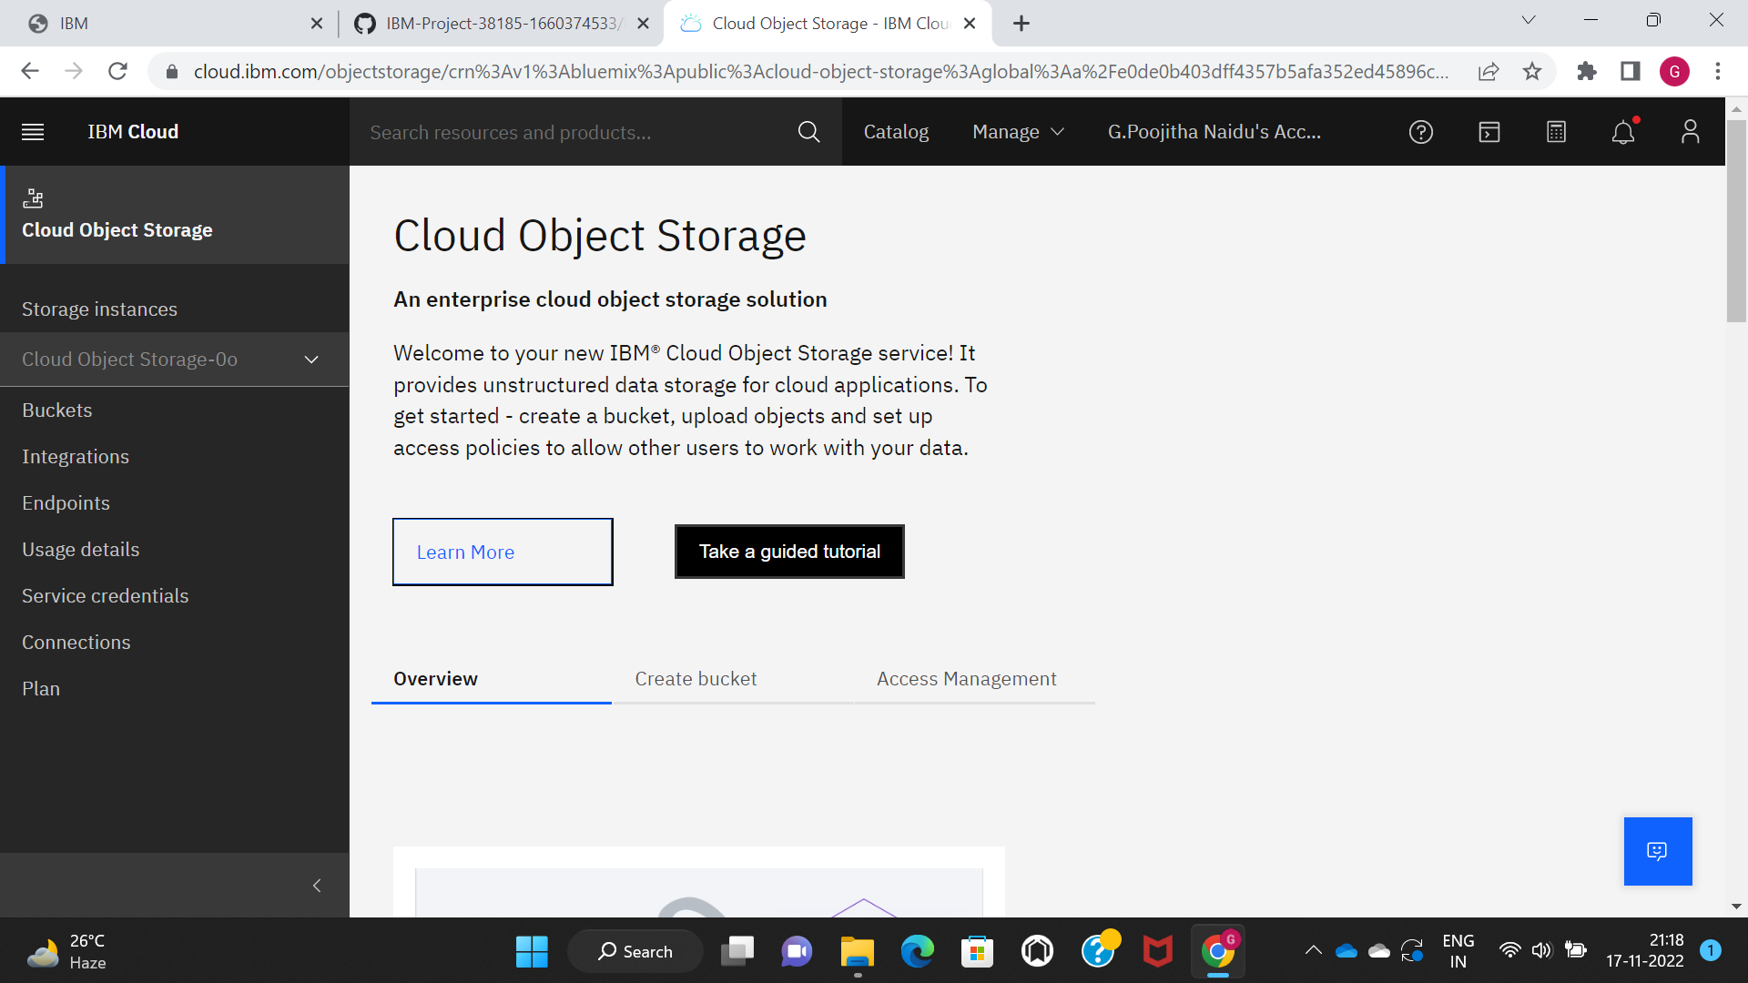

STEP 5: We need to establish a bucket to store the image. Clicking on it will display a few options for creating buckets. Selecting a custom bucket will open as seen below. Enter the information requested, then click the Create Bucket button

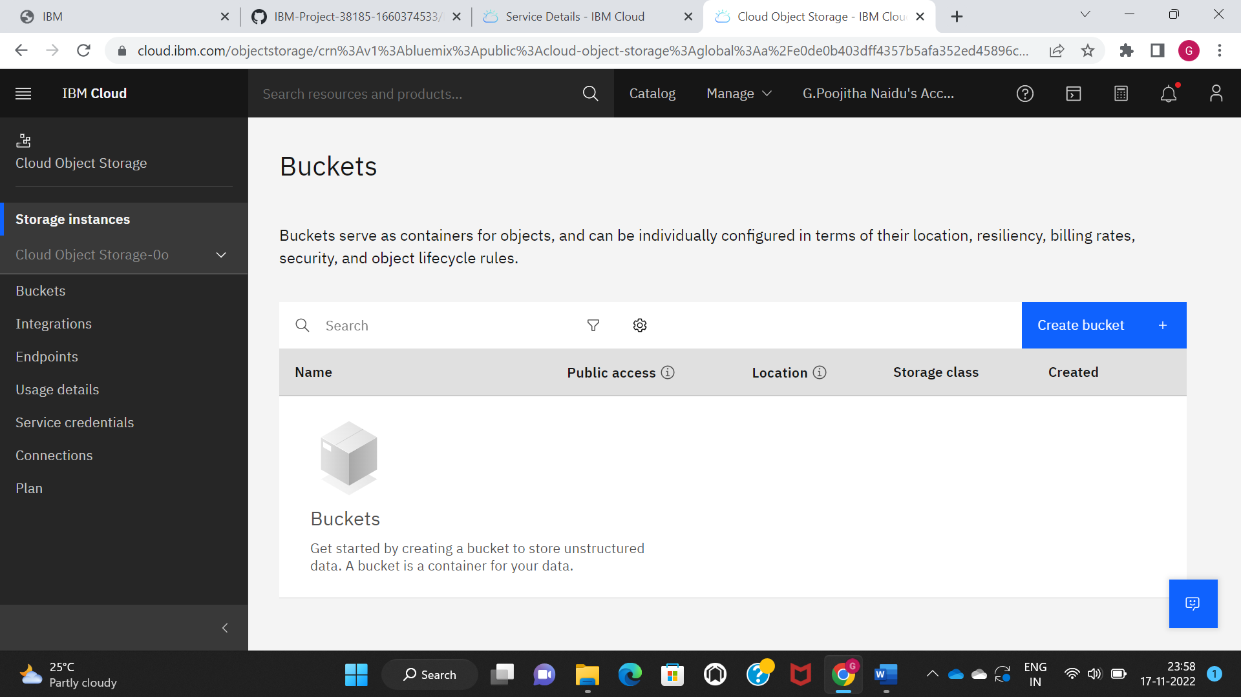

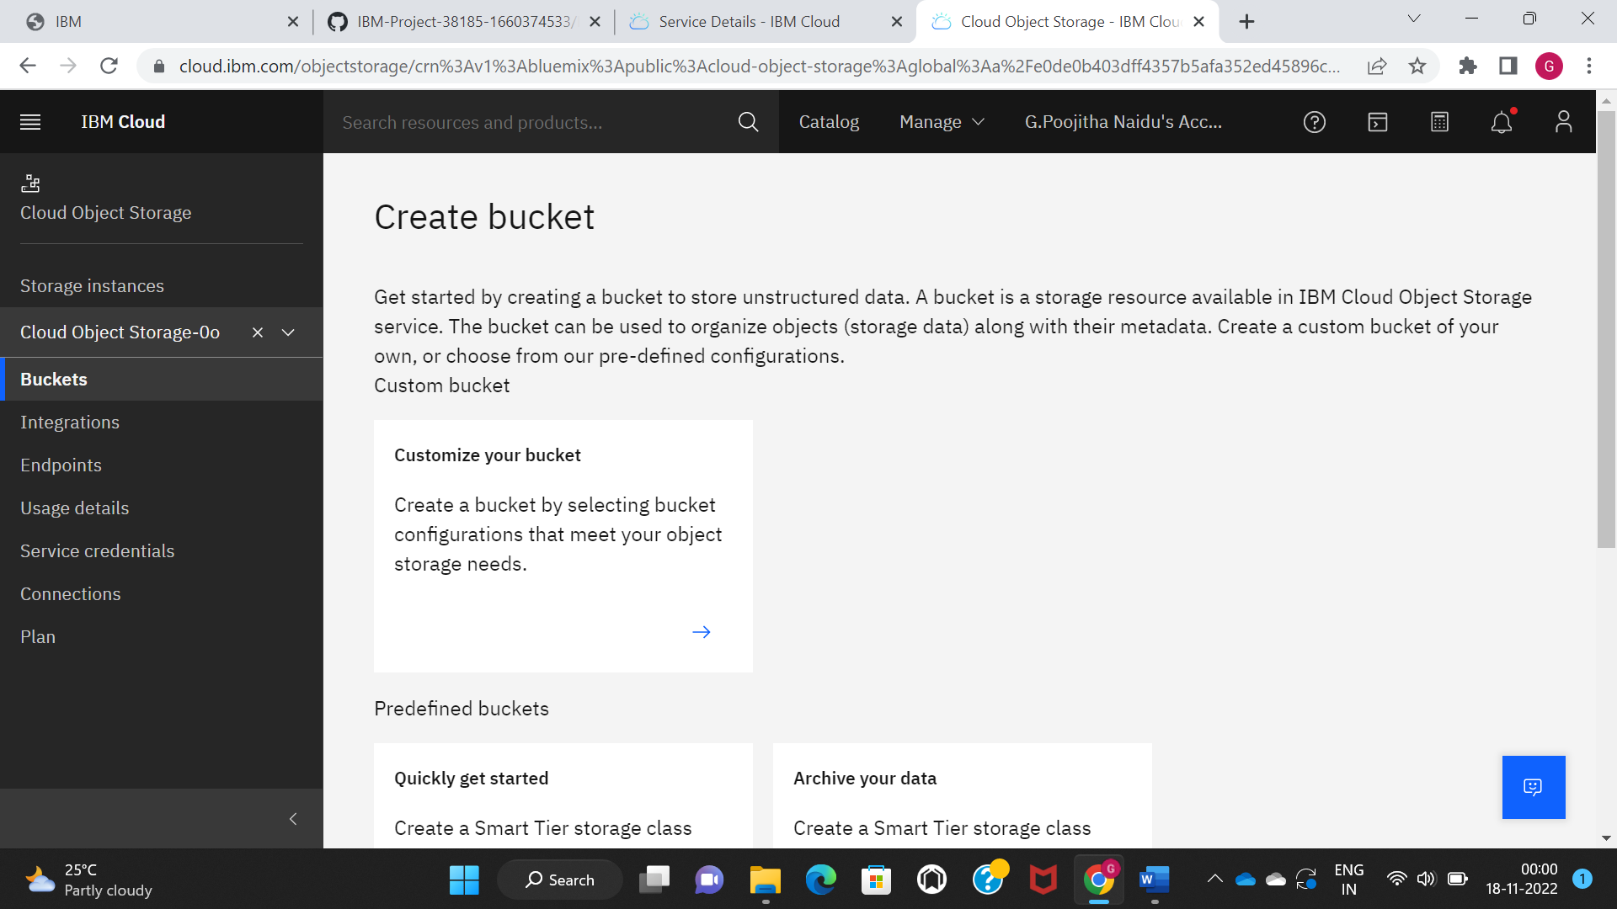

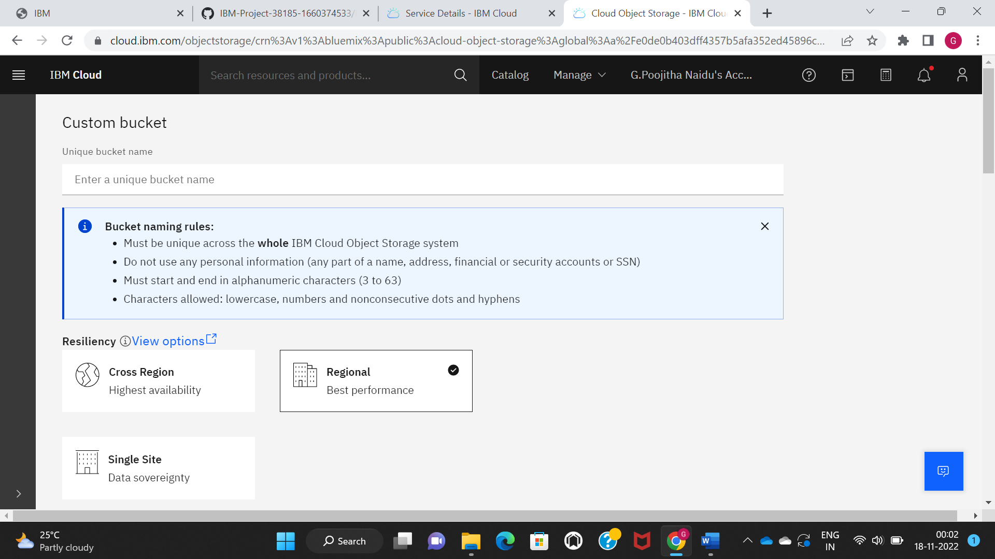

STEP 6: Then you get observe bucket is created successfully. And to store the images drag and drop files shown in below picture.

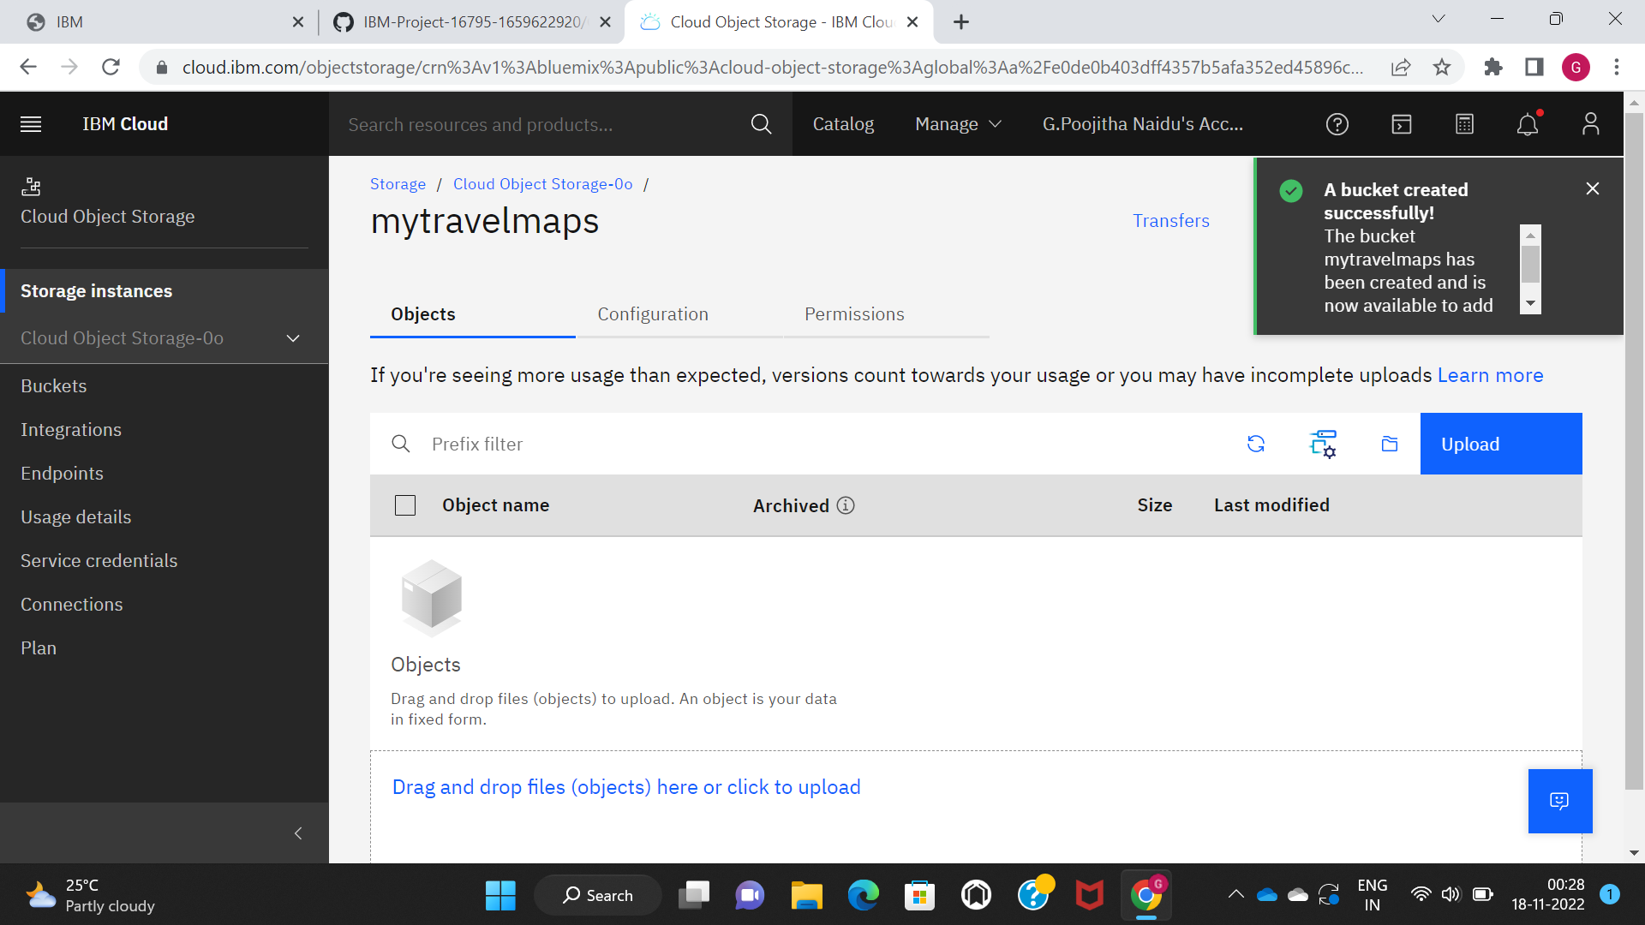

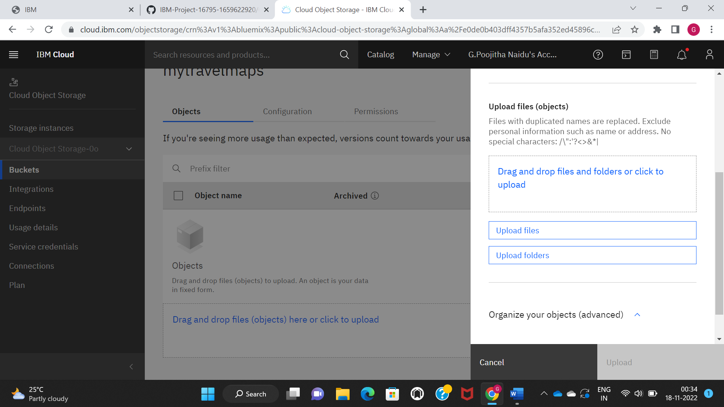

STEP 7: Now you can see observe configuration settings as shown.

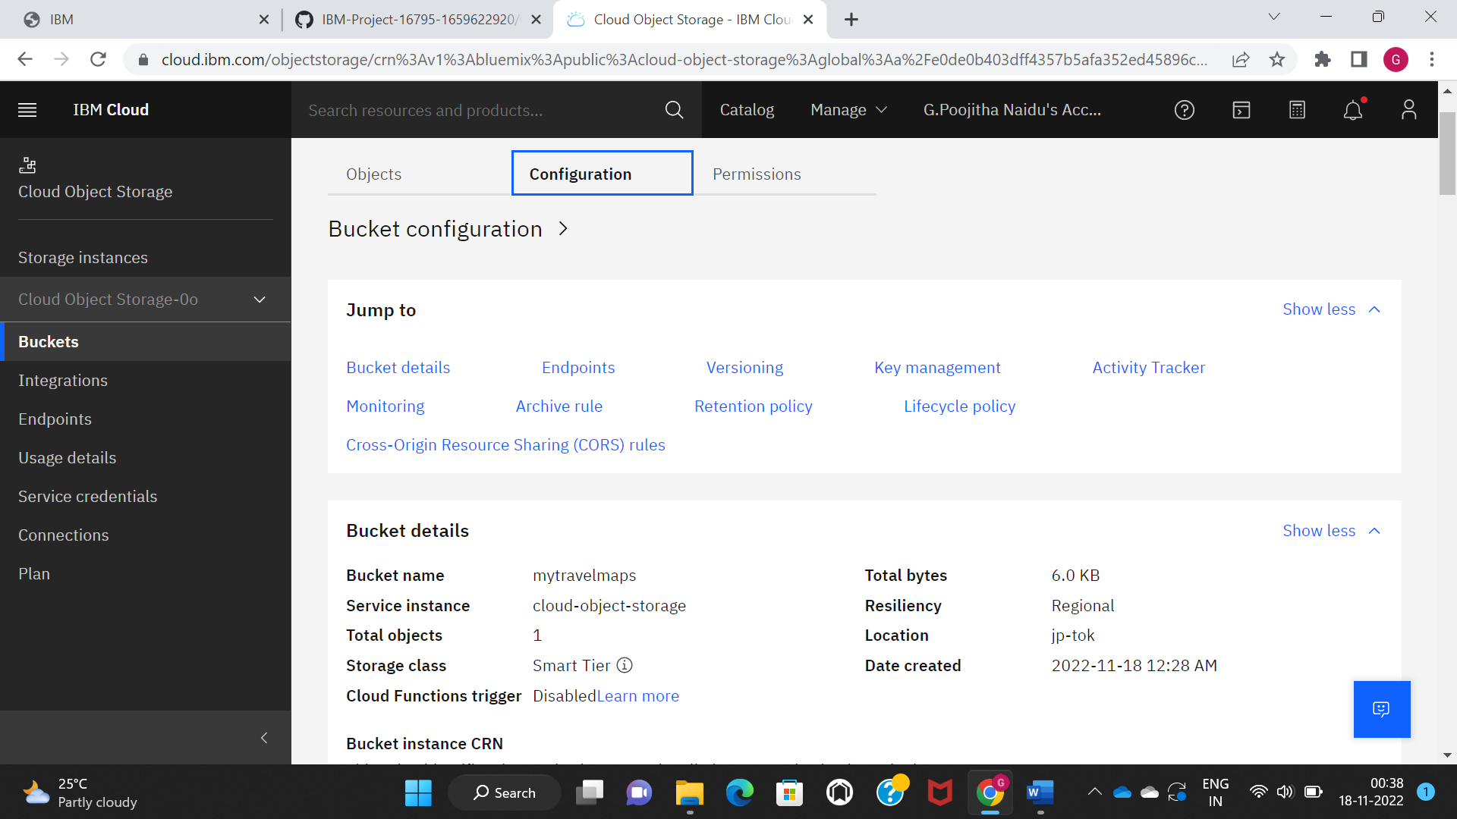

STEP 8: The end points which are used in the programming

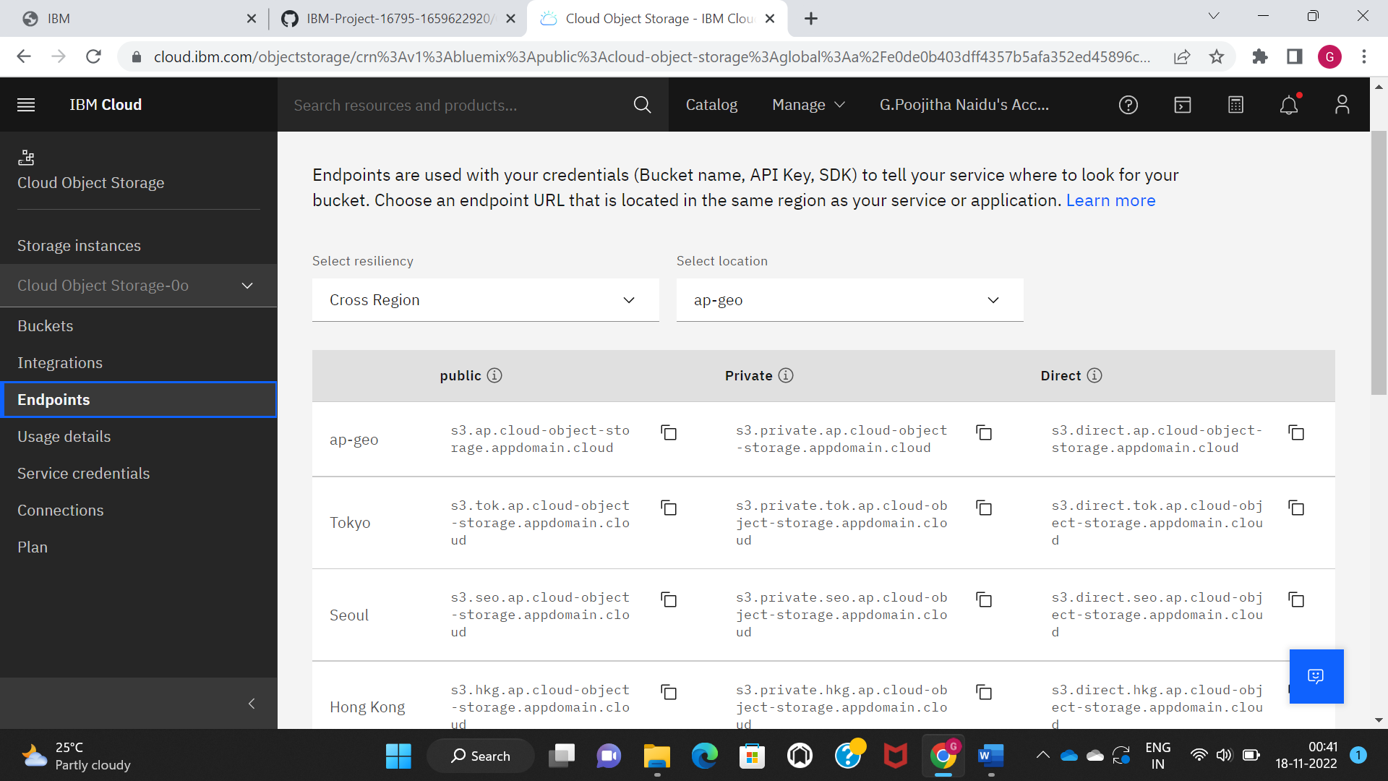

STEP 9: The service credential for the program is given below

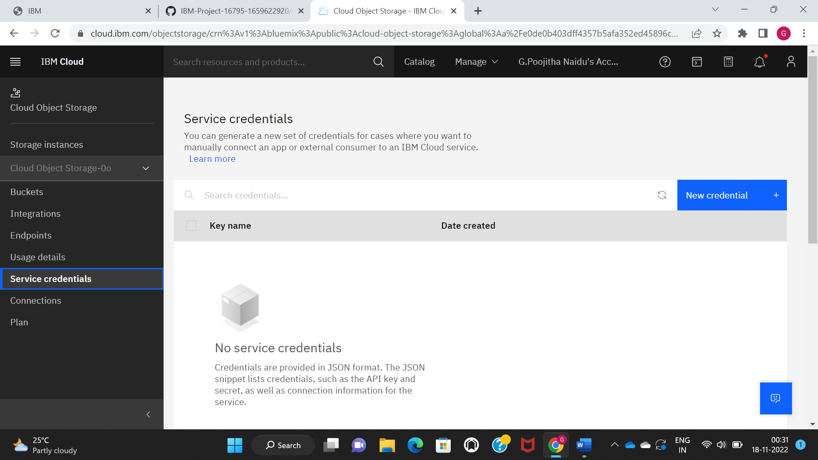

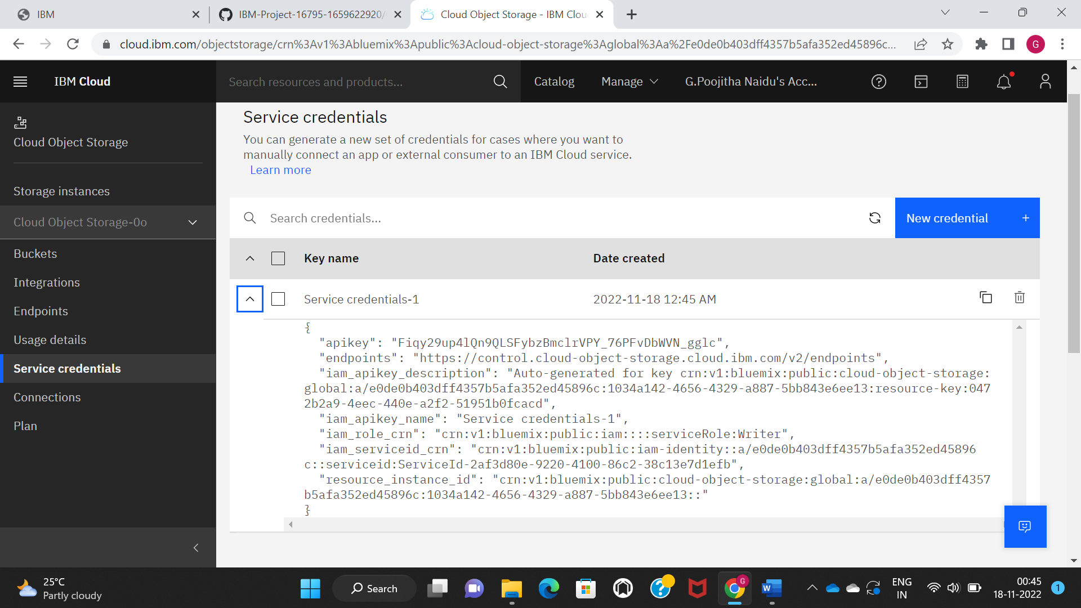

STEP 10: By this way you can create a cloud object storage service, create a bucket to store the image and configure the bucket settings